National Agriculture in the Classroom

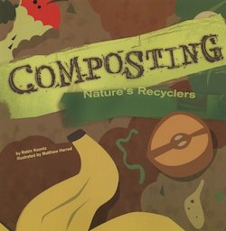

Composting: Nature's Recyclers
Dead leaves, food scraps, and grass clippings for lunch? Small animals, fungi, and bacteria called decomposers turn trash into a tasty compost treat. Learn more about compost and how you can use it in your garden or yard.

Author
Robin Koontz

Lessons Associated with this Resource
- Working Worms
- Vermicomposting (Grades K-2)
- Vermicomposting (Grades 3-5)
- The Rotten Truth
- The Case of the Missing Pumpkin

